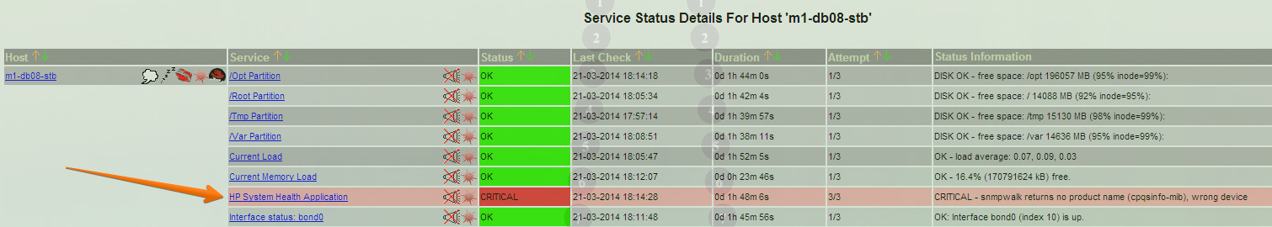

[root@nag2 ~/work/20140320-1743]# check_hpasm --help
check_hpasm 4.6.3 [http://labs.consol.de/nagios/check_hpasm]

This nagios plugin is free software, and comes with ABSOLUTELY NO WARRANTY.
It may be used, redistributed and/or modified under the terms of the GNU
General Public Licence (see http://www.fsf.org/licensing/licenses/gpl.txt).

This plugin checks the hardware of hp/compaq proliant servers

Usage: check_hpasm [ -v|--verbose ] [ -t <timeout> ] --hostname <proliant> --community <snmp-community> ...]
-?, --usage
Print usage information
-h, --help
Print detailed help screen
-V, --version
Print version information
-t, --timeout=INTEGER
Seconds before plugin times out (default: %s)
-v, --verbose
Show details for command-line debugging (can repeat up to 3 times)
--blacklist
Blacklist some (missing/failed) components
--ignore-dimms
Ignore "N/A"-DIMM status on misc. servers (e.g. older DL320)
--ignore-fan-redundancy
Ignore missing redundancy partners
--customthresholds
Use custom thresholds for certain temperatures
--eventrange=<warningrange>/<criticalrange>
Period of time before critical IML events respecively become warnings or vanish
A range is descibed as a number and a unit (s, m, h, d), e.g. --eventrange 1h/20m
--perfdata=[short]
Output performance data. If your performance data string becomes
too long and is truncated by Nagios, then you can use --perfdata=short
instead. This will output temperature tags without location information
--hostname
Hostname or IP-address of the server (SNMP mode only)
--port
The SNMP port to use (default: 161)
--protocol
The SNMP protocol to use (default: 2c, other possibilities: 1,3)
--community
SNMP community of the server (SNMP v1/2 only)
--username
The securityName for the USM security model (SNMPv3 only)
--authpassword
The authentication password for SNMPv3
--authprotocol
The authentication protocol for SNMPv3 (md5|sha)
--privpassword
The password for authPriv security level
--privprotocol
The private protocol for SNMPv3 (des|aes|aes128|3des|3desde)
--snmpwalk
A file with the output of snmpwalk 1.3.6.1.4.1.232
--hpasmcli
A file with the output of hpasmcli
--servertype
The type of the server: proliant (default) or bladesystem
--eval-nics
Check network interfaces (and groups). Try it and report me whyt you think about it. I need to build up some know how on this subject. If get an error and you think, it is not justified for your configuration, please tell me about it. (alwasy send the output of "snmpwalk -On .... 1.3.6.1.4.1.232" and a description how you setup your nics and why it is correct opposed to the plugins error message
[root@nag2 ~/work/20140320-1743]#

[root@nag2 ~/work/20140320-1743]# snmpwalk -On -v 1 -c tcspub 10.217.50.115 1.3.6.1.4.1.232

[root@nag2 ~/work/20140320-1743]# snmpwalk -On -v 2c -c tcspub 10.217.50.115 1.3.6.1.4.1.232
.1.3.6.1.4.1.232 = No Such Object available on this agent at this OID

[root@nag2 ~/work/20140320-1743]# check_hpasm --hostname 10.217.50.115 --community tcspub -v --perfdata=short --protocol 1
CRITICAL - snmpwalk returns no product name (cpqsinfo-mib), wrong device

[root@nag2 ~/work/20140320-1743]# check_hpasm --hostname 10.217.50.115 --community tcspub -v --perfdata=short --protocol 2c
CRITICAL - snmpwalk returns no product name (cpqsinfo-mib), wrong device

[root@nag2 ~/work/20140320-1743]#

[root@m1-db08-stb ~]# cat /etc/snmp/snmpd.conf
rwcommunity 7PhKlcnHbEAplCYzVctn 127.0.0.1
rocommunity tcspub nag2.tcsbank.ru
rocommunity tcspub monitoring2.tcsbank.ru
rocommunity tcspub sim.tcsbank.ru
rocommunity tcspub zabbix-it.tcsbank.ru
rocommunity tcspub cacti.tcsbank.ru
trapsink sim.tcsbank.ru
trapsink zabbix-it.tcsbank.ru
syscontact admins@tcsbank.ru
syslocation VmWare
com2sec notConfigUser default public
group notConfigGroup v1 notConfigUser
group notConfigGroup v2c notConfigUser
view systemview included .1.3.6.1.2.1.1
view systemview included .1.3.6.1.2.1.25.1.1
access notConfigGroup "" any noauth exact systemview none none
dontLogTCPWrappersConnects yes
[root@m1-db08-stb ~]#

[support@centos00 ds-gp-prod]$ scp /media/sf_share/CPQSINFO-MIB.mib bsv@m1-db08-stb:/tmp
bsv@m1-db08-stb's password:
CPQSINFO-MIB.mib 0% 0 0.0KB/s --:-- ETAWrite failed: Broken pipe
lost connection
[support@centos00 ds-gp-prod]$

[root@m1-db08-stb ~]# cp /tmp/CPQSINFO-MIB.mib /usr/share/snmp/mibs/
[root@m1-db08-stb ~]#

[root@m1-db08-stb ~]# service snmpd restart
Stopping snmpd: [ OK ]
Starting snmpd: [ OK ]
[root@m1-db08-stb ~]#

